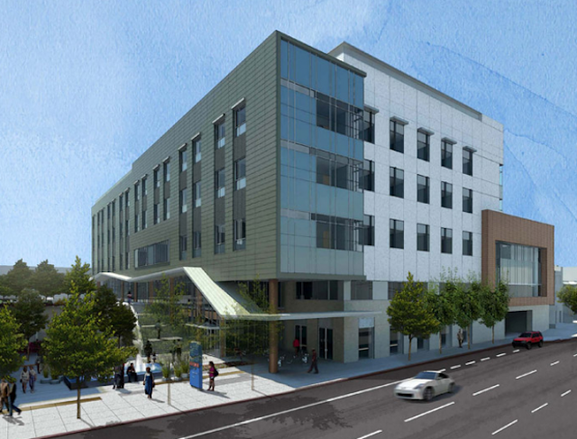

Your Guide

to the New Mission Bernal Campus

May 2 Draft- includes Benney 5/2 edits and phone # corrections based on Pocket Guide

CPMC

Occupancy Manual

Welcome to the Mission Bernal Campus!

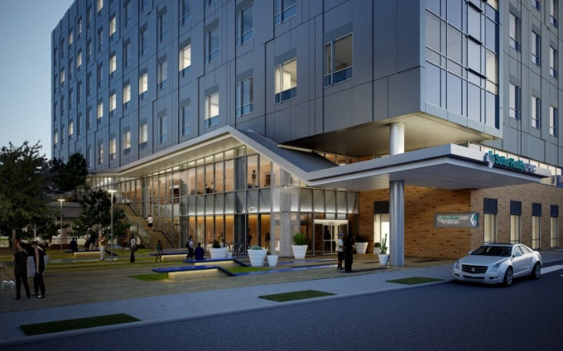We hope you are as excited as we are to begin work at Mission Bernal campus!

This detailed Occupancy Manual. is designed to be your “go-to guide” to help orient you to our new campus.

Retaining the “heart” of what we do

The opening of the new Mission Bernal campus is the culmination of years of hard work, commitment and anticipation. It will continue the legacy of being the neighborhood hospital in the Mission District and retain the “heart” that has made St. Luke’s special for patients, staff, physicians and volunteers alike.

Balancing safety, comfort and sustainability

The new building balances the safety and technical needs of staff, physicians, and volunteers with the comfort and safety of our patients. The modernized campus is seismically safe and certified as *Leadership in Energy and Environmental Design* *(LEE*D), a globally-recognized symbol of sustainability.

The layout of the building is built with a front of house (on stage) and back of the house (off stage) concept. Front of the house refers to all areas that patients and visitors will see, and where we are “on stage” and help create a positive environment for our patients and visitors. Back of house includes Staff Only hallways and elevators. This design will help us put our best foot forward.

Mission Bernal Campus will open on August 25, 2018. We are so pleased to be able to create the next generation in health care services for San Francisco.

Spring 2018

Table of Contents

General X

Important Contacts X

Building Hours and Entrances X

Visitor Badges X

Personnel Identification Badges X

Elevator Usage X

Staff Lockers X

Shared Spaces X

Conference Room Reservations X

Conference Rooms X

Department and Divisions by Floor X

* First Floor X
* Second Floor X
* Third Floor X
* Fourth Floor X
* Fifth Floor X
* Sixth Floor X
* Seventh Floor X

LEED X

Building Reminders X

Parking & Transportation X

Public Transportation X

CPMC Shuttle Schedule and Routes X

Parking X

* Staff Parking X
* Visitor Parking X

Services X

Support Services X

Department Phone Directory X

Volunteers X

Spiritual Care and Chaplaincy Services X

Interpreters X

Respiratory Etiquette Stations X

Wheelchairs and Gurneys X

Lost and Found X

Patient Relations X

Newborn Connections X

Safety and Security X

Security Station X

Security Awareness X

Emergency Department Team X

Door Alarms & Stairwell Access X

Crash Carts  X

Automated External Defibrillator (AED) X

Emergency Management  X

Emergency Operations Plan (EOP)  X

Hospital Command Center X

Communications in Disaster X

Fire Safety X

General Fire Safety  X

Fire Safety Plan  X

Fire Response = RACE X

How to Use a Fire Extinguisher X

New Standardized Emergency Codes X

* Calling a Code X
* Code Gray X
* Infant / Child Safety X
* Code Pink X
* Code Purple  X
* Code Blue X

Responding to a Code Blue or other Medical Emergency……………………..x

What do you do if you get injured? X

Workplace Violence X

MRI Safety X

ADA Information X

Hand Hygiene X

Service Dogs X

Amenities X

Information Desk X

Waiting Areas X

Restrooms X

Bicycle Locker & Showers X

Water Cooler/Bottle Water Refilling Stations X

Dining Services X

Catering Services X

Room Reservation X

Patient Entertainment X

Lactation Lounges X

Ambassador Services Suite X

Guest Internet Access X

Equipment and Furnishing X

Ergonomics X

Office Space & Furniture X

Kronos X

Telephone X

Multi-Function Printers (Scan, Print, Copy) X

Fax X

PBX and Telephone Operating System X

HIPAA – Confidential Document Containers X

Sustainable Waste Removal X

Wayfinding X

Vocera X

Nurse Call System X

Temperature Monitoring X

Patient Lift System and Mobile Lifts X

Pneumatic Tube System X

Supplies and Restocking X

Loading Dock / Deliveries x

Supply Chain……………………………………………………………………………………………………………..x

Supply Chain and Medical Gas Area x

Supply Chain Stat Request x

Pharmacy…………………………………………………………………………………………………………………..x

Equipment Cleaning x

Aeroscout Asset Management x

Staff Duress…………………………………………………………………………x

Durable Medical Equipment (DME) x

Linen Services x

How to Order Forms and Brochures x

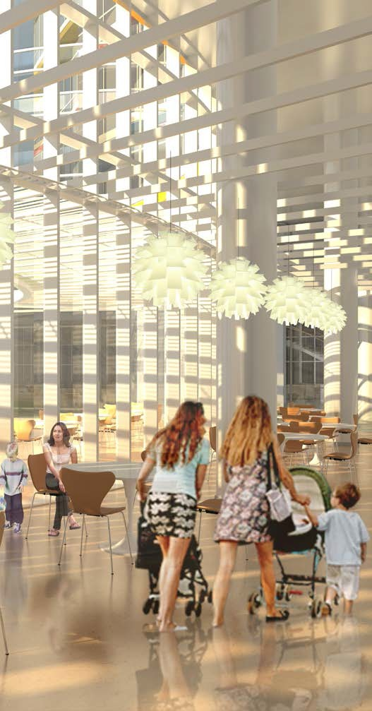

General Building Information

Remove this blank page

Important Contacts THIS IS PLACEHOLDER – IMPORT FROM POCKETGUIDEFINAL

|  |  |  |  |
| --- | --- | --- | --- |
| **Department** | **Current Phone number** | **Extension** | **Department Fax Number (Telecom to Update)** |
| Administration | 415-641-6536 |  | 415-641-7582 |
| Emergency Department | 415-641-6625 | 86625 | 415-641-7598 |
| Bed Control | 415-850-7123 |  |  |
| S3 | 855-398-1631 |  |  |
| Cashier (L2) | 415-641-3333 | 83333 | 415-824-1338 |
| Cardiac Cath Lab | 415-600-5990 | 65990 |  |
| Cardiology | 415-537-8600 | 78600 | 415-369-1370 |
| Case Management | 415-641-6534 | 86534 | 415-821-9657 |
| Chaplain | 415-641-6527 | 86527 |  |
| Clinical Lab | 415-641-6533 | 86533 |  |
| Diabetes Center | 415-600-0506 | 60506 | 415-600-6279 |
| Dialysis (in-patient) | 415-641-3427 | 83427 |  |
| Dictation | 415-641-6860 | 86860 |  |
| Doctor's Dining Rm | 415-641-1204 | 81204 |  |
| Doctor's Lounge | 415-641-6739 | 86739 |  |
| Environmental Services |  |  |  |
| Facilities |  |  |  |
| Hospitalists | 415-912-8469 | n/a | 415-369-1240 |
| Human Resources |  |  |  |
| Information /Lobby | 415-641-6512 | 86512 |  |
| Information Technology |  |  |  |
| Interpreter Services |  |  |  |
| Medical Staff Office | 415-600-6285 | 66285 | 415-750-5012 |
| Medical Records | 415-641-6515 | 86515 | 415-641-7595 |
| Nursing Admin | 415-641-6536 | 86536 | 415-824-1338 |
| **Nursing Stations - New** |  |  |  |
| 4th floor ICU | 415-641-6612 | 86612 | 415-824-1364 |
| 4th floor PCU | 415-641-6610 | 86610 | 415-824-1361 |
| 5th Floor Med Surg | 415-641-6690 | 86690 | 415-824-1370 |
| 6th floor Med Surg | 415-641-6710 | 86710 | 415-824-1368 |
| 7th floor FBC | 415-641-6630 | 86630 | 415-824-1382 |
| 3rd Floor ACU | 415-641-6889 | 86889 |  |
| 3rd floor OR | 415-641-6635 | 86635 |  |
| Pathology | n/a | n/a |  |
| Patient Relations | 415-600-6634 |  |  |
| Pharmacy | 415-641-6505 | 86505 | 415-641-0577 |
| **Department** | **Current Phone number** | **Extension** | **Department Fax Number (Telecom to Update)** |
| Pulmonary Lab | 415-641-6616 | 86616 | 415-641-7585 |
| **Radiology/Imaging** | 415-641-6545 | 86545 |  |
| Breast Health | 415-641-6545 | 86545 |  |
| CT | 415-641-6545 | 86545 |  |
| MRI | 415-641-6545 | 86545 |  |
| Ultrasound | 415-641-6545 | 86545 |  |
| **Registration** | 415-641-6951 | 86951 |  |
| Emergency Dept | 415-641-6698 | 86698 | 415-641-7597 |
| Main Hospital | 415-641-6951 | 86951 | 415-641-7583 |
| Monteagle - (Lab Pre-Reg) | 415-641-3351 | 83351 | 415-641-3350 |
| Pre-Reg | 415-641-6736 | 86736 | 415-865-4176 |
| **Rehab and Therapy** |  |  |  |
| Occupational Therapy | 415-641-6560 | 86560 | 415-641-3426 |
| Physical Therapy | 415-641-6560 | 86560 | 415-641-3426 |
| Respiratory Therapy | 415-641-6565 | 86565 | 415-641-7585 |
| Speech Therapy | 415-641-6560 | 86560 | 415-641-3426 |
| Security Dispatch | 415-600-0837 | 60837 |  |
| Support Services | 415-600-7900 | 67900 |  |
| **Surgery** |  |  |  |
| OR Front Desk | 415-641-6635 | 86635 | 415-641-6587 |
| Outpatient Surgery | 415-641-6889 | 86889 |  |
| PACU | 415-641-6638 | 86638 |  |
| Scheduling | 415-600-6900 | 66900 |  |
| Women's Center | 415-641-6996 | 86996 |  |
| Main Hospital | 415-600-6000 |  |  |
| Volunteer Office | 415-641-6538 | 86538 |  |

## Building Hours and Entrances THIS IS PLACHOLDER. IMPORT FROM POCKET GUIDE FINAL NOTE CHANGE ON BOTH FOR Plaza- it is 24/7 do we need to state what “after hours” is for badging? If so, it’s 8p-7a

## 

## Visitor Badges

## Visitors and vendors who are coming to the hospital will be required to wear Visitor Badges between 8 pm and 7 am. They may sign-in and receive badges at two locations: have we confirmed this? I would think we are only doing this at the Security Desk on Level 2

* The Information Desk in the Public Lobby
* The Security Desk on Level 1 or Level 2

## Photo identification is required for those 18 years and older. Children without an ID will also receive a badge as long as they are accompanied by an adult. Visitor Badges will become void after 8 - 12 hours and will need to be reissued.

## Patients/visitors going to appointments in the Medical Office Building will not require a badge.

## **If someone needs assistance to enter the building**

## Should an individual arrive at the Cesar Chavez St. entrance and need assistance (ADA accommodation), he/she should use the phone at the entrance to contact Security. A security officer will then assist the individual into the building.

## Personnel Identification Badges

## Providers, staff and volunteers must wear their hospital identification badges while on campus. Badges are required for identification and to gain access to non-public areas and devices.

## **Staff must tap their badge to the respective device, to activate the corresponding system.**

## Registry staff is required to show registry ID before being issued a badge. Hospital issued badges must be return to the charge nurse at the end of the shift.

## Internal stairwells may be used for exiting the building; however badge access is required on the ground floor for re-entry.

## You will need your badge if you are moving from one floor to another.

## Do not let anyone use your badge.

## Pay attention to your surroundings when badging in and ensure that no one enters behind you.

## If you forgot your badge, please go to the Security Desk for a temporary

## badge.

## 

|  |  |  |
| --- | --- | --- |
| **Examples** | | |
| **General Entry with Badge Access** | **Restricted Areas****Badge Clearance Required** | |
| All exterior doors with card readersAll back of house space (hallways, etc.)Multidisciplinary/ Conference RoomsConsult RoomsBicycle StorageLocker RoomsEmergency DepartmentImaging EntranceM/S, L&D and M/S Patient Floors (unless otherwise specified)Service elevators | Administrative SuiteAdmittingBiomedical EngineeringClean/Soil Utility RoomClinical LabFood & Nutrition AreaMaterials Mgmt/Supply ChainMedical Equipment RoomsMedrooms | MorgueMRI SuitesNourishment RoomsNursery/SCNPBXPharmacyPT/OT AreaSecuritySPD, OR, PACU/ACU |

## Elevators

## There are two sets of elevators on the campus. Please yield to patients being transported.

## Four public elevators are available for patients and visitors. Badge access is not required (**GREEN**).

## Three transport/service elevators are for staff, volunteers and patient transport. Badge access is required to activate elevator (**RED**).

Staff Lockers

Lockers are available for staff use in department areas (see table below).

* All lockers will be day use only, unless otherwise designated by management
* Lockers accept padlocks and are two or three high.
* Department managers are responsible for handling locker buddy assignments and distribution.

|  |  |
| --- | --- |
| **Department Lockers** | **Location** |
| Pharmacy | Level 1 |
| Kitchen | Level 1 |
| Materials Mgmt, EVS, Biomed, Engineering | Level 1 |
| Emergency Department | Level 2 |
| Imaging | Level 2 |
| Surgery, Prep/Recovery, PACU, CSPD | Level 3 |
| Lab | Level 3 |
| ICU | Level 4 |
| Medsurg | Level 4 & 5 & 6 |
| Respiratory Therapy | Level 4 |
| LDR | Level 7 |

Shared Spaces

Mission Bernal Campus is designed with a shared work space design.

**Multi-disciplinary workrooms** are conference-style type rooms on patient care floors. These rooms accommodate ten people sitting around a rectangular conference table and may be used for small group meetings, education sessions, and so forth. The rooms are equipped with a large wall monitor and teleconferencing.

**Inter-disciplinary workrooms** are individual computer workstations in a shared workroom environment. Workstations are not to be “claimed” for any specific individual use. Practice shared workspace etiquette; keep the volume down, no eating and clean up after yourself.

**Consult rooms** are designed for providers to have private conversations with patient family member(s) and significant others. Rooms may be locked; requests keys from the charge nurse. Please clean the room after every use.

**Family rooms** are public areas for family members to sit and gather, outside the patient room.

There are two **On-Call rooms**, 5361 or 5359, available for scheduling. Contact Support Services at x77900 (415-600-7900) or use the *Online Room Scheduling Portal* at http://dcpwdbs405/virtualems/ QUESTION FOR TAMI to reserve a room up to a week in advance. Same day or after-hours requests can be directed to the hospital Operator or the Nursing Supervisor.

**Staff Lounges** are for non-physician staff. Nursing staff is responsible for cleaning the coffee maker.

Conference Room Reservations

There are conference rooms on the 1st and 2nd floors, available for hospital and public use. Conference Rooms A & B (1st floor) and Room 2910 (2nd floor).To reserve a conference room, go to the online room scheduling portal at <http://dcpwdbs405/virtualems/>.

* Each room is equipped with large monitors and teleconferencing.
* Rooms will be locked after hours, by Security, and re-opened by Security.
* There will be video displays outside of these rooms that will provide meeting schedules

QUESTION FOR TAMI

Conference Rooms

Conference rooms are available on the patient care floors for patient care team use.

Floor conference rooms are dedicated to the floor. Oversight and scheduling of these rooms lie with the Nurse Manager. In general, these can be used for small classes, inservices, and department meetings

Department and Divisions by Floor

### Mission Bernal Campus is a seven-story, 120 bed, full service medical center with an emergency department and supporting services, including imaging services, and laboratory. The building is thoughtfully designed to enhance patient comfort, be environmentally conscience, seismically safe, and support current and future technologies.

### A department phone directory is on page XX.

### TAMI: Per Jim B, we need an updated chart from you

### 

### 

Placeholder – Eric will change levels to floors.

### 

## ERIC To import final Pocket Guide for all floor maps and descriptions

## First Floor Main Areas

|  |  |
| --- | --- |
| Bicycle StorageBiomedCafeteriaCesar Chavez EntranceCentral DistributionConference Rooms A & BLoading Dock | EVSLoading DockLocker Rooms & ShowersPharmacyPhysician Dining/Lounge |

## 

## Second Floor Main Areas

|  |  |
| --- | --- |
| Admitting/Cashier/Request of Information27th/ER/Ambulance EntranceImaging | Information DeskMeditationVending MachinesWaiting Area |

## 

Third Floor Main Areas

|  |  |
| --- | --- |
| Ambulatory Care UnitOperating RoomsPACUSterile Processing | Nursing AdministrationAmbassador ServicesClinical Lab |

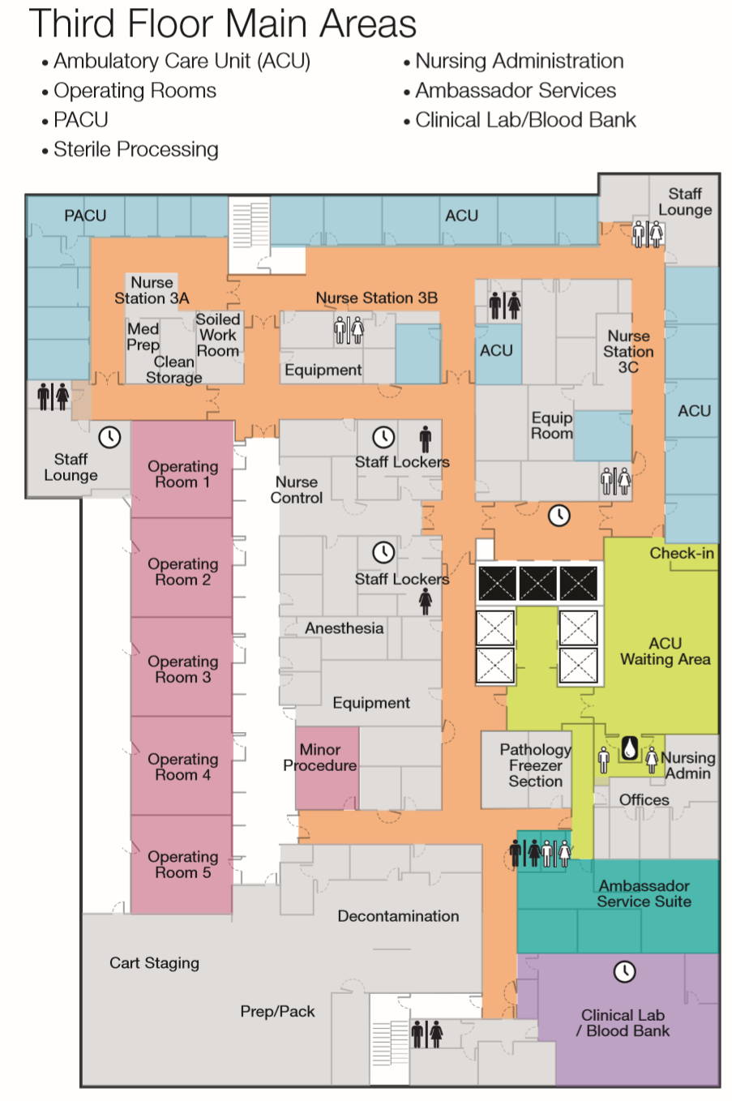

Fourth Floor Main Areas

|  |  |
| --- | --- |
| ICU (10 beds)Progressive Care Unit (20 beds) | Respiratory Care |

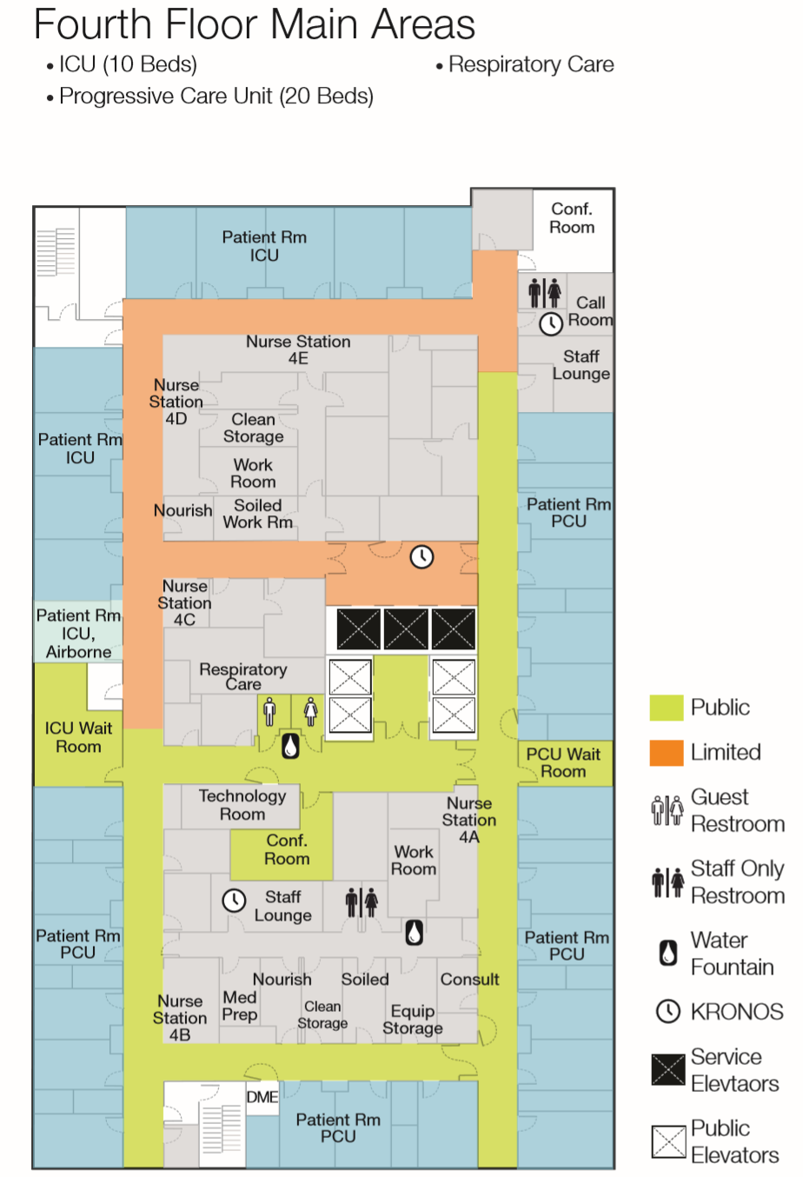

Fifth Floor Main Areas

|  |  |
| --- | --- |
| Med/Surg (34 beds)PT/OT Exercise Room | Dialysis Workroom |

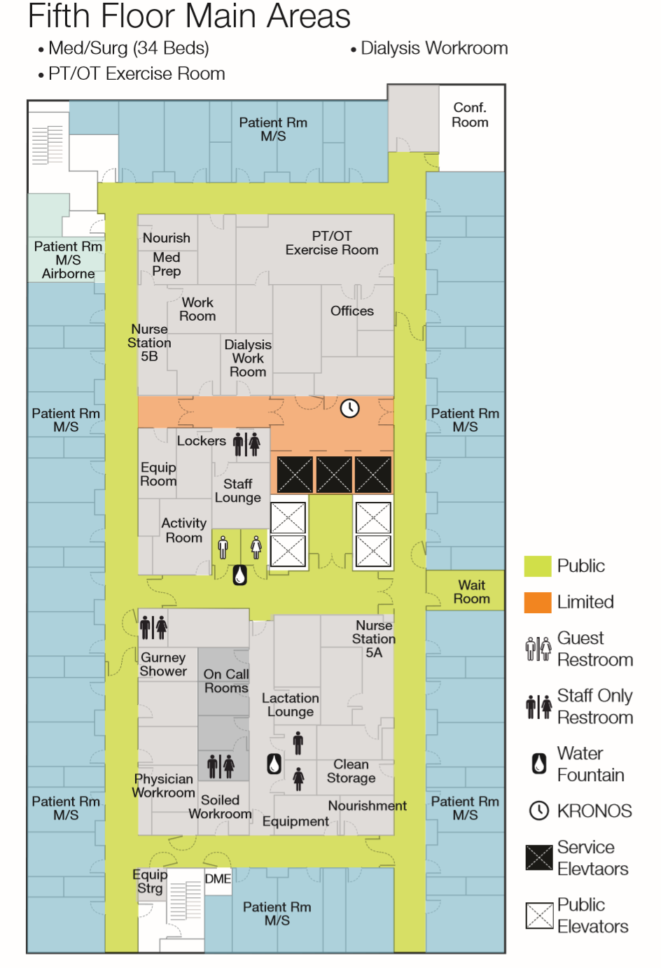

Sixth Floor Main Areas

|  |
| --- |
| Med/Surg Patient Rooms (34 beds)Non-Invasive Cardiology (Inpatient) |

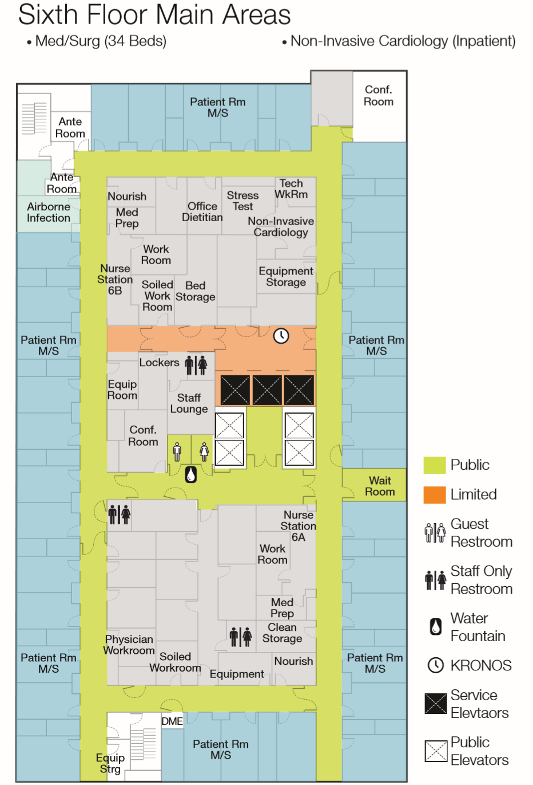

Seventh Floor Main Areas

|  |  |
| --- | --- |
| Antepartum/Postpartum (16 beds)C-SectionLabor and Delivery (6 beds) | Special Care (4 beds)Well Baby Nursery |

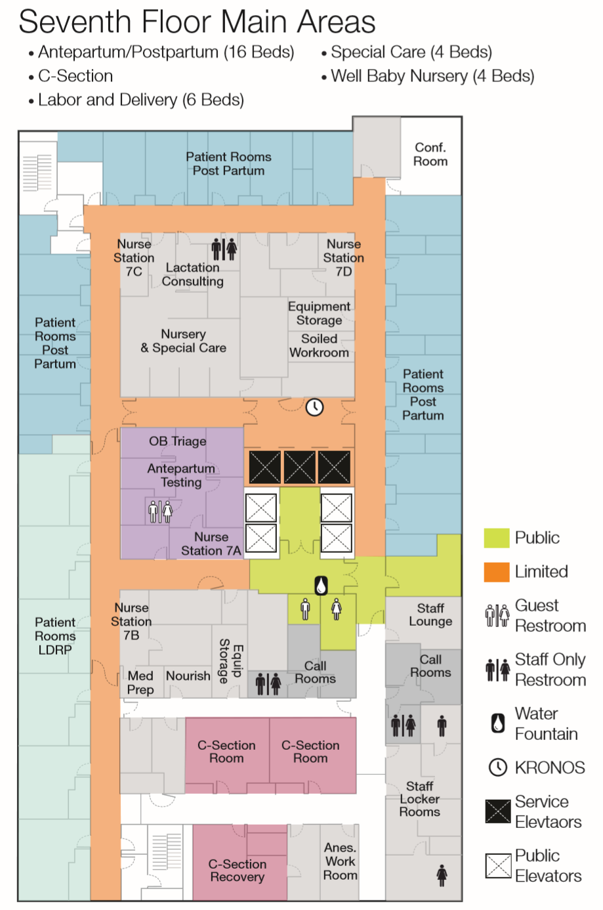

## Sustainability

The campus is *Leadership in Energy and Environmental Design (LEED)* certified, a globally recognized symbol of sustainability. The building is constructed to lower greenhouse gas emissions by reducing the use of energy and water.

A new pedestrian plaza is designed to be an urban oasis with shade trees and plantings and to help with water drainage. Approximately 360,000 gallons of storm water will annually be diverted from the City’s water system. In addition, about 50,000 gallons of rainwater will be diverted to help dissipate heat from the heating, ventilation and air conditioning (HVAC) system at the building’s rooftop cooling towers.

Bottle water refilling stations (pg. X) and the sustainable waste removal program (pg. X) are other examples of ongoing sustainable processes.

## Building Reminders

* + - * Remember you are “on stage” in front of house areas (areas that patients and visitors will see)
      * Help create a positive environment for our patients and visitors.
* **No** moving furniture or equipment in the building
* **No** hanging things on the wall (art and bulletin boards provided)
* **No** fish or pets of any kind will be permitted, with the exception of service animals (pg. xxx)
* Personal packages will no longer be accepted at the campus. Materials Management will not sign for it.
* Ordering food for delivery—Staff are responsible to come down to the second floor Security Desk to pick up food. Food delivery will not be allowed to come to the care department.



Parking, Transportation, and Shuttles

## Public Transportation

CPMC encourages visitors and staff to follow San Francisco's Transit First policy and use alternative modes of transportation whenever possible. The Mission Bernal Campus is easily accessible by a combination of rail, bus, shuttle, ferry and/or bicycle. Visit [**511.org**](http://www.511.org) for a comprehensive list of transit options to spare the air and keep our campuses safer for you and your families.

Complimentary shuttle services to and from Mission Bernal Campus to 24th St. Mission BART station is available for staff, physicians, volunteers, patients and their families. Shuttle service is available every 30 minutes, Monday – Friday, 6:00 a.m. to 6:00 p.m. Verify with RIgo – you should actually review this with Craig Oats and/or David Roney

Patients and visitors may also obtain additional information on public transportation and shuttle timetables at the Information Desk. Staff and providers may visit our Intranet for additional public transportation and shuttle service information.

## CPMC Shuttle Schedule and Routes

Verify with Rigo you should actually review this with Craig Oats and/or David Roney

Additional inter-campus shuttles are available to staff, providers, patients and their families. Shuttle service is available every 30 minutes, Monday – Friday, 6:00 a.m. to 6:00 p.m.

## Shuttle stop locations.

## . Ask your shuttle driver regarding courtesy stops.

|  |  |
| --- | --- |
| Shuttle Name | Route |
| B | Civic Center BART station to Pacific Campus |
| C | California Campus to Pacific Campus |
| D | Davies Campus to Pacific Campus |
| K | Kabuki Hotel to Pacific Campus |
| MBC | Mission Bernal Campus to Davies Campus |
| JG | Japantown Garage to Pacific Campus |
| GG | Geary Garage to California Campus |
| SAC | 1825 Sacramento to Civic Center BART station |
| MBC24* | Mission Bernal Campus to 24th St. Mission BART station |

Eric, see Intranet for shuttle pick up locations and import here. Verify with Rigo you should actually review this with Craig Oats and/or David Roney

## Parking

### Staff Parking

In addition to the Cesar Chavez Street Garage, two other offsite parking lots have been made available to provide 40 more parking spaces during business hours. These parking lots are within a five minutes walking distance. Security escorts are available if needed. The Cesar Chavez Street Garage is available to staff after hours and on weekends.

# Parking is limited, so please take public transportation whenever possible.

# 

### Visitor Parking

* Visitor parking is available for patients and their families. , The entrance to the parking structure is on San Jose Ave.
* Payment machines are on every level, by the elevators. Payment machines accept cash and credit cards. Please pay before exiting; cashiers are not stationed at the exit gates.
* Level P1 has van accessible spaces and spaces for oversized vehicles.



# SERVICES

Support Services

Support Services are comprised of CPMC departments such as Environmental Services, Facilities, Engineering, Biomedical Engineering, Materials Management, and Nutrition & Food Services. At Mission Bernal, they are located on the First Floor (see page xxx.)

#### Department Telephone Directory

#### The Microsoft Outlook Address Book is application to access the Employee ~~Department~~ Phone Directory for ~~all~~ CPMC and Sutter Health~~campuses~~. The standard process for adding / changing staff locations will synchronize with the address book to keep the directory accurate without additional administrative work. Department Phone Directory by campus is located in our Intranet.

#### Use the advanced search on the address book for quick lookups.

#### A list of Important Department phone numbers in Mission Bernal Campus can be found on page X.

Volunteers

At the Mission Bernal Campus, volunteers help at the Information Desk, provide hospitality, escort patients, and help with selected non-clinical patient care activities. CPMC offers volunteer opportunities to students and adults.

The Mission Bernal Volunteer Office is located in the 1912 Bldg. See page xxx. The telephone number is 415-641-6490.

Spiritual Care and Chaplaincy Services

The CPMC Spiritual Care Team provides spiritual care to patients, families and staff inclusive of all religious traditions, cultural backgrounds and spiritual expression. The Spiritual Care Team offers or arranges for the practice or experience of religious sacraments and rituals such as baptism, blessings, communion, sacrament of sick, confessions, chanting..

In addition, the team is available to support’ families and loved ones. The Spiritual Care Team is available to visit patients 24/7 on all four campuses. Call 415-641-6527 to request a Chaplain visit for your patient.

## Interpreter Services

Our Interpreter Services Program offers the following services:

* [In-person interpreting by professionally trained medical interpreters](http://intranet.chop.edu/sites/language-services/in-person-interpreting.html)
* Video interpreting via an iPad
* T[elephonic interpreting](http://intranet.chop.edu/sites/language-services/telephonic-interpreting.html) via a dual handset phone system
* A dual handset interpreter phone is stored in the nurse server in every Med/Surg patient room

These services are available to all departments at no cost. Please access Interpreter Services by calling x61077 or 415.600-1077.

## Respiratory Etiquette Stations

To prevent the transmission of respiratory infections, complimentary respiratory etiquette stations with gloves, antibacterial gel, and masks are available in the main registration areas and on each floor.

## Wheelchairs and Gurneys

Wheelchairs and gurneys are available for general patient use and are tagged with Aeroscout RFID (GPS tracking devices) to facilitate ease of location for patient use. Equipment will be cleaned after each patient use by clinical or transport staff.

## Lost and Found

## Lost and found is located in the 1912 building on the 4th floor CONFIRMED?. Please confirm this with Milo Fanene. I do not believe it is on the 4th floor, in the future state. I believe it is on the 3rd floor. Please contact Security at 415-600-0837 if you have a missing item that cannot be located.

## For patient lost and found items, please direct them to Security or contact Patient Relations at 415-600-6634.

## Patient Relations

## Patients are at the center of everything we do. If a patient or a family member has a question or concern about their hospital stay, they are encouraged to tell their care team. They may also contact Patient Relations at **415-600-6634** or ask a nursing supervisor.

## The Patient Relations team can address:

## Lost patient items (coordinate an investigation, conduct a follow-up, facilitate reimbursement)

## Assist with difficult patient/family incidents

## Coordinate patient grievance issues to align with regulatory standards

## Coordinate ADA concerns

## Meet with patients/families to de-escalate issues before they become grievances

## Round on patients (in addition to nursing leadership rounds)

## Patient experience (facilitate trainings and in-services to help staff improve the patient experience)

## Newborn Connections

Newborn Connections is a community resource new to Mission Bernal campus that offers support and education from pregnancy through early parenting. Located in the Monteagle Building, the program includes prenatal classes, massage services, breastfeeding support, and support groups, as well as breastfeeding, baby, and lactation supplies.

Hours are Monday – Thursday, 9 a.m. to 6 p.m., Friday, 9 a.m. – 4 p.m. Closed Saturday and Sunday. The telephone number is 415.600-2229.

COVER PAGE/NEEDS ARTWORK

Safety and Security

Security Station

The main Security Station for the Mission Bernal Campus is located on the second floor at the 27th Street main entrance / Emergency Department (ED) entrance. Security enhancements include:

* A metal detector at the ED entrance.
* Panic alarms are located in identified high risk areas; when activated, a silent alarm is sent to Security Dispatch.
* Security stations are located at key main entrances to include the ED and loading dock.
* Staff Duress buttons on Aeroscout RFID tags worn by staff

Security Awareness:

* Be aware of your surroundings.
* ***If you see something – say something***
* For emergency situations (other than Code Blue) dial **4-4444.**
* Keep your personal property especially purses, briefcases and bags locked and secure.
* Pay attention to person(s) who look suspicious or look like they don’t belong.
* Make sure vendors have a vendor badge.
* Wear your hospital badge.
* Be alert when you are in areas or around people that are unfamiliar to you.

For general security concerns or for an escort to your vehicle, contact Security Dispatch at **x60837 (415.600-0837).**

### Emergency Department (ED) Team

The ED team will respond to all non-patient emergencies in the main hospital.

### Door Alarms & Stairwell Access

### JIM B TO PROVIDE COPY..Leave space for two paras

### Crash Carts

Crash carts are strategically located throughout the Mission Bernal Campus in the event of a medical emergency for patients, visitors or staff.

### Automated External Defibrillator (AED)

AEDs are in two locations on the first floor of the campus:

* Outside the Conference Rooms A and B
* Outside the Cafeteria 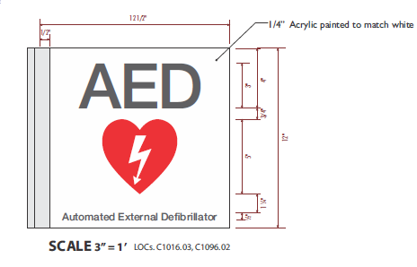

Emergency Management

Emergency Operations Plan (EOP)

Emergencies, disasters and other catastrophic events pose a significant threat to the ability of a health care organization to maintain operational capability and provide care, treatment, and services to its community.

CPMC has implemented a comprehensive *All-Hazards Emergency Operations Plan* to respond to the medical needs of the community in the event of an emergency, disaster situation, or a mass casualty incident.

The *All-Hazards Emergency Operations Plan* is an organization-wide program that incorporates all services and sites of care under the CPMC license. This plan applies to staff, licensed independent practitioners, contract workers, volunteers and others as appropriate and indicated throughout this document.

The *All-Hazards Emergency Operations Plan* complies with the elements of the National Incident Management System (NIMS), incorporates the Hospital Incident Management System (HICS), and addresses the six critical areas mandated by Joint Commission standards:

* Communications
* Resources and assets
* Safety and security
* Staff responsibilities
* Utilities management
* Patient clinical and support activities

*The full plan is located on the CPMC Intranet*

DON’T NEED A SECTION BREAK

Hospital Command Center

The hospital uses the Hospital Incident Command Structure (HICS) to manage emergency events and if the situation warrants the Emergency Operations Plan would be activated via Code Triage.

If Code Triage is initiated, the Hospital Command Center (HCC) will be activated and is located on the first floor in Conference Room A and B. If additional resources are needed to manage the event, the Labor Pool will be activated and is located in the hospital cafeteria.

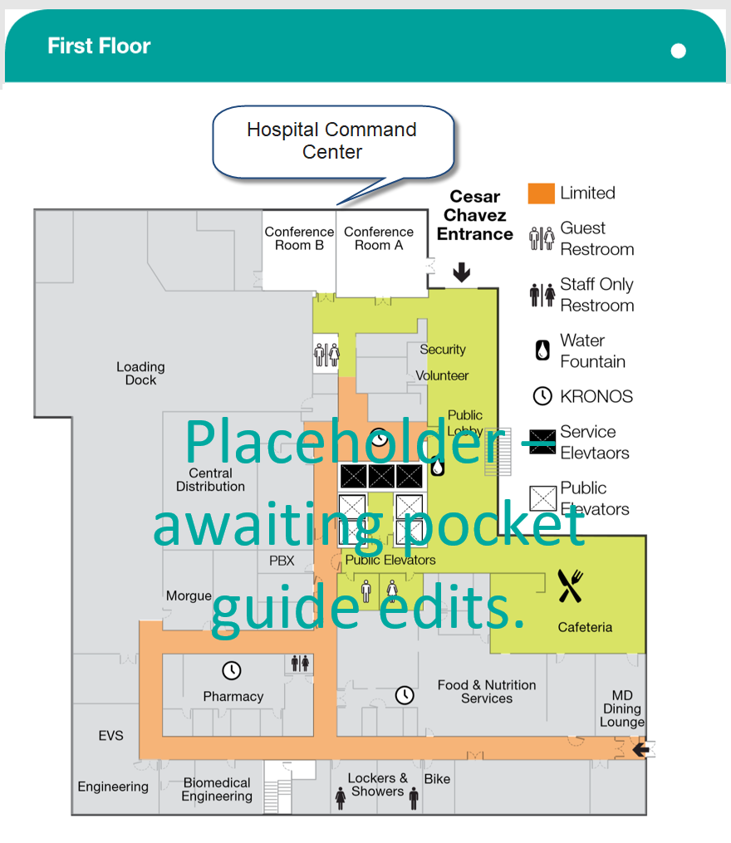

Communications in a Disaster

Sutter Health affiliates use Everbridge Mass Notification System to communicate to all staff simultaneously in a disaster or other type of emergency. Everbridge has been implemented to improve the efficiency and effectiveness of communications. The system-wide notification system enables CPMC staff to receive and respond to critical safety and business impact information in a timely manner.

Everbridge allows CPMC to communicate with staff via multiple contact paths including home phone, email, mobile phones and other communication devices during an emergency event.

**What to do when a notification is received**:

* Read (when received via email) or listen to the message carefully for directions
* “Confirm the Message” when asked by clicking on the link provided in the email, or “press 1” if the message is received via phone.
* The purpose of confirming the message is so that CPMC knows that you have received the message.

Having accurate contact information is critical for Everbridge to work effectively and staff to receive emergency information. In some cases, personal contact information such as cell and home are inaccurate or missing in Lawson. Everbridge pulls from Lawson and unless your personal information is accurate you may not receive emergency notifications.

**How to update your personal contact information**:

Check the ***Lawson*** **e-Self Service** site on the Intranet Portal to confirm your personal contact information is correct.

Please direct questions regarding Everbridge to the Safety Department at

**415-600-4620** or email is sforzok@sutterhealth.org.

**Fire Safety**

### General Fire Safety

### Leave room here for 3 more short paras from Jim Benney

Never block access to pull stations, fire extinguishers and medical gas value boxes. Corridors should be clear except for crash cards, isolation carts or “in use equipment.” If the fire alarm is activated, make sure corridors are clear.

* During an actual fire or smoke event, do not use elevators. Follow exit signs to the nearest, safest exit stairwell.
* Do not open doors if they are hot to touch, or if you can see smoke. If you become trapped in a room, and cannot exit safety, keep the door closed and seal off any cracks. Call hospital operator at 4-4444 and report your exact location.
* If a door feels cool to the touch, open it cautiously. Be prepared to slam the door shut if the corridor is full of smoke or if you feel heat when opening the door. If the corridor is clear, proceed with evacuation.
* If you are caught in smoke or heat, stay low until you reach a safe area such another smoke compartment.

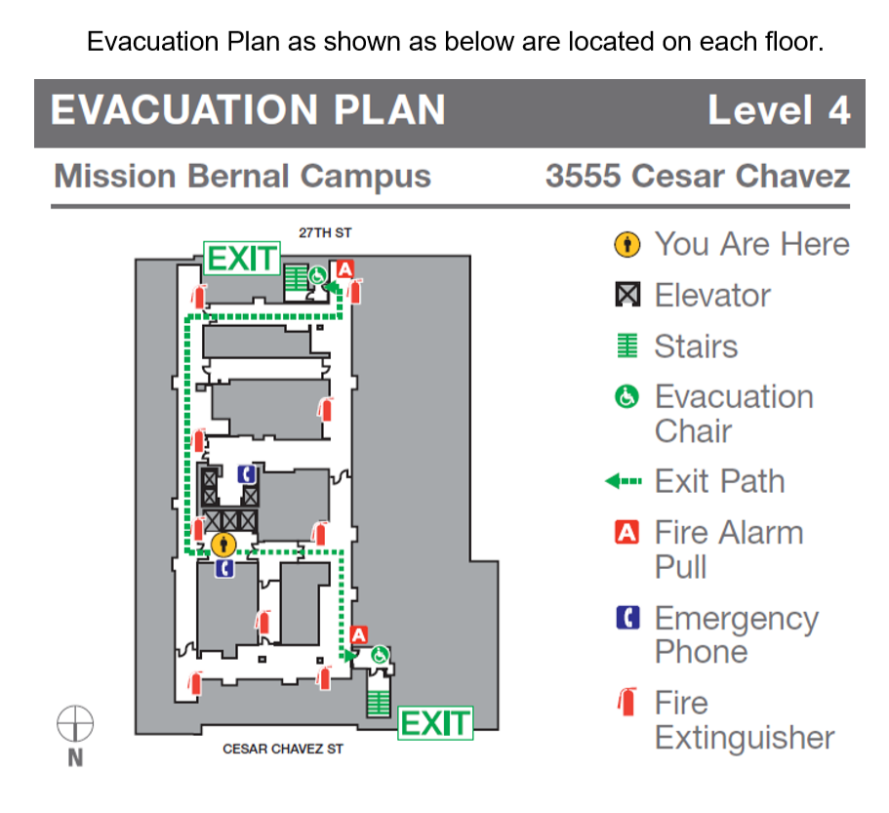

Fire Safety Plan

* Smoking is prohibited in all buildings and vehicles.
* Check cords and equipment.
* Report problems.
* Know where pull stations and fire extinguishers are located.
* Know evacuation routes – stop and look – where are the exit signs.

Fire Response = RACE

**Rescue** – Rescue/remove person(s) from the immediate danger.

**Alarm** – Active the nearest fire alarm pull station, then call 44444 and/or 911.

**Confine** – Confine fire and smoke by closing all doors in the area.

**Extinguish or Evacuate** – extinguish a small fire by using a portable fire extinguisher or use to escape from a large fire. Evacuate the building **ONLY** upon order of the Incident Commander or the Fire Department.

How to Use a Fire Extinguisher – PASS

### 

STANDARDIZED EMERGENCY CODES

|  |  |  |
| --- | --- | --- |
| **Emergency Code** | | **Definition and Announcement** |
| **CODE BLUE**   * **Adult** * **Maternity** * **Pediatric** * **V.A.D.** | Cardiac or respiratory arrest  ANNOUNCEMENT: "Code Blue (Adult, Maternity, Neonate, Pediatric, or V.A.D.) - *location"* | |
| **CODE GRAY** | Combative Person (aggressive, hostile, combative or potentially combative persons)  ANNOUNCEMENT: "Code Gray - *location"* | |
| **CODE ORANGE** | Hazardous Material Spill/Release  ANNOUNCEMENT: "Code Orange - Hazardous Materials Spill/Release - *location"* | |
| **CODE PINK** | Infant Missing or Abducted (infants/children up to 2 years of age) ANNOUNCEMENT: "Code Pink last seen - *location insert description (e.g. age, gender, race,) of missing infant and description (e.g. age, gender, race, clothing) of individual that may be with, if available."* | |
| **CODE PURPLE** | Child/Adult Missing or Abducted (child/adult over the age of 2) ANNOUNCEMENT: "Code Purple (child or adult) - last seen - *location and description (e.g. age, gender, race, clothing)"* | |
| **CODE RED** | Fire  ANNOUNCEMENT: "Code Red - *location"* | |
| **CODE SILVER** | Person with a Non-firearm Weapon and/or Hostage Situation ANNOUNCEMENT: "Code Silver - location. A security threat exists at location. All persons should immediately move away from that location if it is safe to do so. If it is not safe to move away, seek shelter or remain in a room with the door closed until an all clear has been announced." | |
| **Code Silver - ACTIVE SHOOTER** | ANNOUNCEMENT: "Code Silver - active shooter - location. A security threat involving a firearm exists at location. All persons should immediately move away from that location if it is safe to do so. If it is not safe to move away, seek shelter or remain in a room with the door closed until an all clear has been announced." | |
| **CODE LIME** | Electronic health record is down.  ANNOUNCEMENT: "Code Lime - initiate (EPIC, PACS, other) downtime procedures." | |
| **CODE SEPSIS** | A patient is in septic shock and needs emergent attention. ANNOUNCEMENT: "Code Sepsis - location." | |
| **CODE TRIAGE, INTERNAL/ EXTERNAL ALERT/ ACTIVATE** | Disaster/MCI/patient surge event. Activate Emergency Operations Plan for internal or external incident.  ANNOUNCEMENT: "Code Triage Internal/External – Alert – situation*." OR "Code Triage Internal/External – Activate – situation*. The emergency operations plan has been activated" When applicable the following should be added to the announcement: "Incident management team members should proceed to the location for a briefing."  *NOTE: Plain language should be used to describe the "situation." For | |
| **CODE YELLOW** | Bomb Threat (a bomb threat or the discovery of a suspicious device or item) ANNOUNCEMENT: "Code Yellow - location." | |

|  |  |
| --- | --- |
| **Medical Alerts** | **Definition and Announcement** |
| **C-SECTION** | A pregnant patient needs an emergent C-section. ANNOUNCEMENT: "Medical Alert: C-section - *location."* |
| **ECMO** | A patient needs emergent extracorporeal life support. ANNOUNCEMENT: "Medical Alert: ECMO (infant, child, or adult) - *location."* |
| **IMMINENT DELIVERY** | A pregnant patient in advanced stages of labor cannot be transported to the Labor & Delivery Unit prior to delivery and needs emergent attention. ANNOUNCEMENT: Medical Alert: Imminent Delivery - *location."* |
| **MASSIVE BLOOD TRANSFUSION** | A patient emergently needs a massive blood transfusion. ANNOUNCEMENT: "Medical Alert: Massive Blood Transfusion - *location."* |

|  |  |
| --- | --- |
| **RAPID RESPONSE** | A patient with early signs of clinical deterioration needs emergent attention to prevent respiratory or cardiac arrest.  ANNOUNCEMENT: "Medical Alert: Rapid Response - *location."* |
| **SEPSIS** | A patient has severe sepsis and needs urgent attention. ANNOUNCEMENT: "Medical Alert - Sepsis - *location."* |
| **STEMI** | A patient with myocardial infarction and ECG evidence of ST elevation needs emergent percutaneous coronary intervention. |

### Code

Code Gray

Will be initiated for any event with aggressive, hostile, combative, or potentially combative behavior from a patient, visitor, or staff member, without the display of weapons.

Response Procedures

At the first indication of a perceived Code Gray:

* Dial the emergency number 4-4444
* Describe the incident to the operator, including the specific location
* Security will determine when an “All Clear” will be announced.

Post Incident

* Security will conduct a post investigation debriefing. You will be interviewed to gather incident specific information.
* Complete the Workplace Violence Incident Report and, if applicable, an electronic *Report of Injury* (eROI), Patient Safety Report (PSR) and Quality Risk Assessment.

Infant / Child Security

There is an Infant Security System installed in Women’s and Infant Center (Labor & Delivery, Nursery, NICU & Pediatrics) to protect our infants and prevent infant abductions. Code Pink and Code Purple are used in the event of a missing infant or child.

Code Pink

Code pink is initiated when an infant or child less than 2 years of age is discovered missing or has been abducted.

**Staff response to a missing or abducted infant/child**

* Call the emergency number (4-4444) the moment an infant/child is confirmed missing or abducted.
* State an infant/child is missing or abducted and provide:
  + Your name and the location where the infant/child was last seen.
  + The infant/child’s name and physical description (age, gender, race, etc.).
  + Any additional details about the abduction or absence (e.g. description of the abductor).

**Staff Response to a Code Pink Announcement**

* Immediately stop all non-critical work and proceed to your department’s pre-assigned area(s) to observe stairwell door, elevator areas and exit doors. If outside of your department, monitor the nearest exit. Continue monitoring until “Code Pink” – All Clear” is announced.
* Identify and report suspicious individual(s) to the emergency number (4-4444).
* Respectfully engage anyone who is carrying an infant or may be concealing an infant. Explain the situation and request to inspect objects.
* If the suspected abductor flees, do not forcibly restrain them. If safe to do so, follow them taking note of their appearance, what they are wearing and how the exit the building.
* If the suspect abductor reaches the parking lot and attempts to leave by car, take note of the vehicle’s make, model, color and license plate.

Code Purple

Is initiated when a child/adult over the age of 2 is discovered missing or has been abducted.

**Staff should initiate a “Code Purple” when the missing child/adult:**

* Is a minor.
* May have been removed from the facility against their will.
* Has a central line, IV, PICC Line, catheter, etc.
* Is awaiting Psychiatric Emergency Service evaluation.
* Poses a danger to themselves or others as documented by physician.
* Is on a conservatorship.
* Anytime a clinician has concerns with the patient leaving the facility.

**Staff response to a missing or abducted child/adult:**

* Call the emergency number the moment a child/adult is confirmed missing or abducted.
* State a child/adult is missing or abducted and provide:
* Your name and the location where the child/adult was last seen.
* The child’s/adult’s name and physical description (age, gender, race, etc.).
* Any additional details about the abduction or absence (e.g. description of the abductor).

**Staff response to a Code Purple Announcement:**

* Immediately stop all non-critical work and proceed to your department’s pre-assigned area(s) to observe stairwell doors, elevator areas and exit doors. If outside of your department, monitor the nearest exit. Continue monitoring until “Code Purple – All Clear” is announced.
* Identify anyone matching the description of the missing child/adult and call the emergency number.
* Respectfully engage anyone who is carrying a child or may be concealing a small child. Explain the situation and request to inspect small objects.
* Identify anyone in obvious distress (struggling, needing assistance, appearing lost/confused, etc.) and call emergency number.
* If the suspect flees, do not forcible restrain them. If safe to do so, follow them taking note of their appearance, what they are wearing and how they exited the building.
* If the suspect abductor reaches the parking lot and attempts to leave by car, take note of the vehicle’s make, model, color and license plate.

Responding to a Code Blue or Other Medical Emergency

If you witness a patient, visitor or staff member who is in cardiac and/or respiratory distress, or having a medical emergency, immediately seek medical-nursing assistance by calling for help–and by dialing 5-5555 from a hospital phone.

Patient care areas should also use the Code Blue alarm system **and** alert the hospital Operator by dialing 5-5555.

For other types of urgent medical situations (Rapid Response) and non-medical emergencies (Code Red, Code Gray, etc.), dial 4-4444 from an in-house phone, provide nature of emergency, your name and location.

**Note: For patient and non-patient emergencies in the 1912 or Monteagle Bldgs, call 911.**

Code Team

The Code Team will respond to all patient medical emergencies in the main hospital and will respond to non-patient emergencies only if requested Code Blue (5-5555) is called. The Code Team is multi-disciplinary, made up of ICU physicians, nurses, respiratory therapists, security, and a nursing supervisor.

What do you do if you get injured?

Employees are required to report all work-related injuries and/or illnesses to their supervisor or the on-duty supervisor immediately and complete an Electronic Report of Injury Form (eROI) by the end of shift in which the injury or illness occurred. The forms are located on the CPMC Intranet under *Frequently Reviewed Forms – Environment of Care*.

Upon completion and submission of the form, an incident analysis will be completed by the employee’s manager to determine what caused the incident and actions needed to be taken to prevent the incident from reoccurring.

Workplace Violence Reporting

Effective April 1, 2017, employees working in inpatient and outpatient settings and clinics on hospital licenses are required to report workplace violence incidents into the *Midas Workplace Violence Incident Report*.

Adopted on October 20, 2016, certain health care facilities as defined by the new Cal/OSHAWorkplace Violence Prevention Plan standards, Section 3342, California Code of Regulations Title 8, are required to maintain a log of all incidents of workplace violence by April 1, 2017.

The purpose of the new standard is to protect employees, physicians, volunteers, and contracted personnel from aggressive and violent behavior. For example, physical and/or verbal assault, sexual assault, threats, and violation of a restraining order.

In addition, if an employee is injured in a workplace violence incident they must complete anElectronic Report of Injury (eROI) Form **AND** a Workplace Violence Incident Report.

If a patient is injured, the employee must go to the Hospital Midas Tools Page and complete a patient injury form.

Safety, security, human resources, risk management, and operations management will coordinate a post incident investigation.

MRI Suite Safety

For security and safety reasons, access to MRI suite is limited to MRI personnel and security and is **controlled**. The MRI spaces are zoned to protect staff, patients and families. Zoning is noted as follows:

* Zone II: Unscreened MRI patients, personnel and visitors
* Zone III: Screened MRI patients, personnel and visitors
* Zone IV: Screened MRI patients, personnel and visitors under constant supervision of trained MR personnel

Any metallic, electronic, magnetic or mechanical implants, devices, or objects are hazardous in the MRI Suite and cannot be allowed in the area. Follow and respect instructions from the MRI technologist.

The MRI suite is has a special designated EVS closet with non-metallic supplies and equipment. Regardless, EVS staff should never enter the MRI suite without supervision from an MRI technologist.

Finally, to ensure all zone protocol is followed, always check with MRI technologist before entering the suite.

ADA Information

Assistance for the hearing, listening, visually and speech impaired are available and contact information can be found below:

* **MySutter Portal: Interpreter Services & Multilingual Resources** http://mysutter/SHWBR/CPMC/Resources/MoreResources/Pages/InterpreterServices.aspx
* For **American Sign Language Interpreter** Services, (sign language only, not languages such Spanish, Chinese, etc.) To schedule an ASL interpreter:
  + - Use the **Online Interpreter Scheduling** system or
    - Call our ASL vendor at 1-800-975-8150.
* For **Assistive Listening Systems** (Pocket Talkers), call campus security at 415-600-0837 or ext. 60837.
* For an **Amplified Telephone Handset,** call 74000 or 888-888-6044.
* **Closed caption decoders -** Closed captioning feature is available on all TVs in patient areas. In patient rooms, closed captioning can be activated by pressing the pillow speaker “CC” button.
* **For a braille, large print or audio format provider**, call LightHouse for the blind and visually impaired at 415-694-7358 (braille) and 415-694-7312 (audio) or by email at [ais@lighthouse-sf.org](mailto:ais@lighthouse-sf.org).

Hand Hygiene

Through our Aeroscout Hand hygiene system, we will be able to monitor and record our hand hygiene events, including number of hand washing and location in patient care areas over Wi-Fi. Hand hygiene benefits:

* Enables Infection Control and Process Improvement staff to focus on compliance, education and data analysis.
* Does not disrupt routine patient care workflows.
* Providing automated data collection and reporting.
* Drives accountability down to the caregiver level.

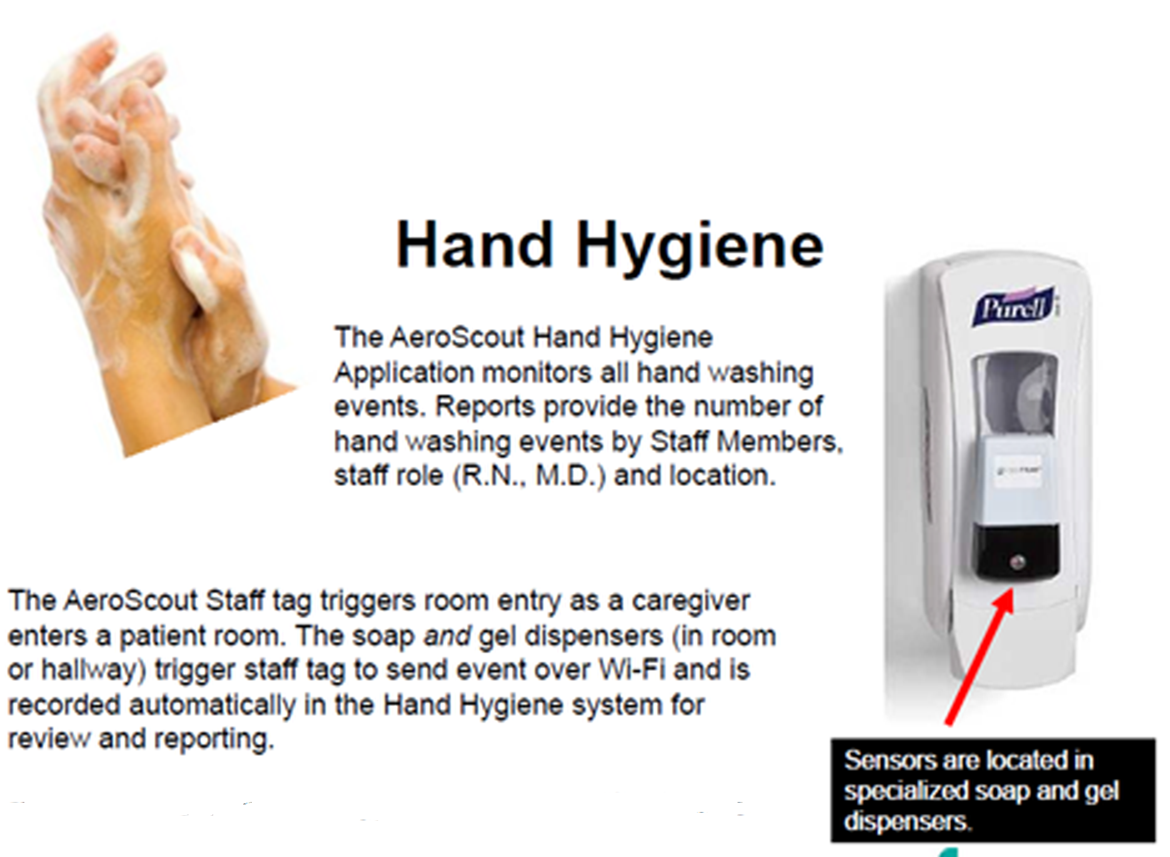

Service Dogs

Service dogs don’t require proof of certification or medical documentation to enter public patient care areas. If you are unsure if the animal is a service dog, you may ask the following:

1. Is the dog required because of a disability?
2. What work or tasks has the dog been trained to perform?

No other questions about a person’s disability or the dog are permitted.

Remember

* Always ask permission to approach the service dog.
* Address the person directly.
* Do not draw unnecessary attention to the person with the service dog.
* Ask how to accommodate the dog during the medical appointment or hospital stay. If necessary, ask who is designated to care for the dog during the medical procedure or hospital stay.

In an Emergency

If the patient can communicate, ask who they want to care for their dog to determine how best to care for the patient and service dog.

If the patient is unable to communicate:

* Look for identifying information on the dog’s harness or collar to determine if the dog came from a school or training program. Contact the school or training program.
* If no information is available, contact family members or friends.
* Contact animal control after all options are exhausted.

Please contact Tim Hern, ADA Coordinator at 415-561-1304 with any questions or concerns.

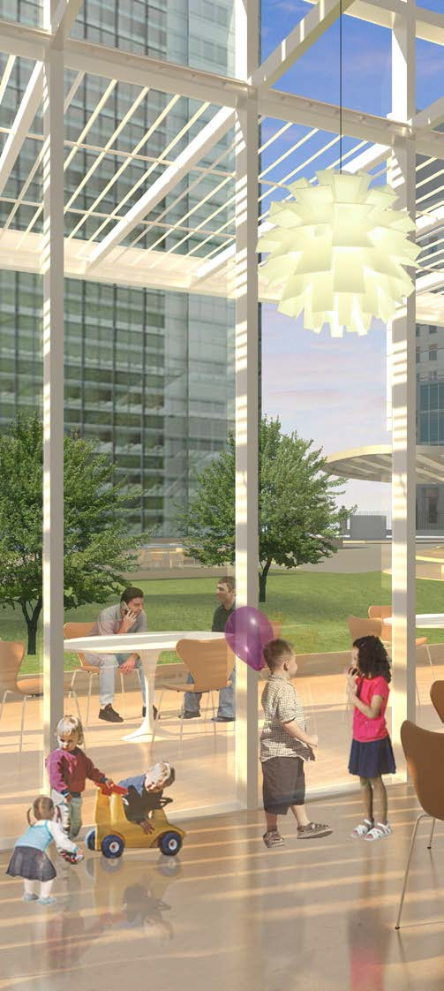

Amenities

Information Desk

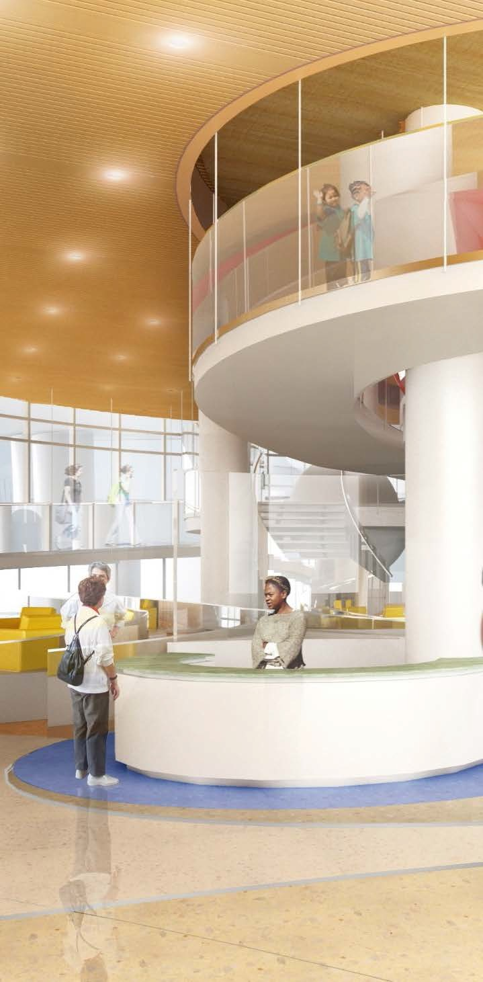

*Figure 1: Welcome Desk*

The Mission Bernal Campus Information Desk is located on the second floor off the Plaza Entrance. The Information Desk staff provides the following services:

* General information
* Directions and wayfinding
* Shuttle schedule information
* Taxi and transportation services information

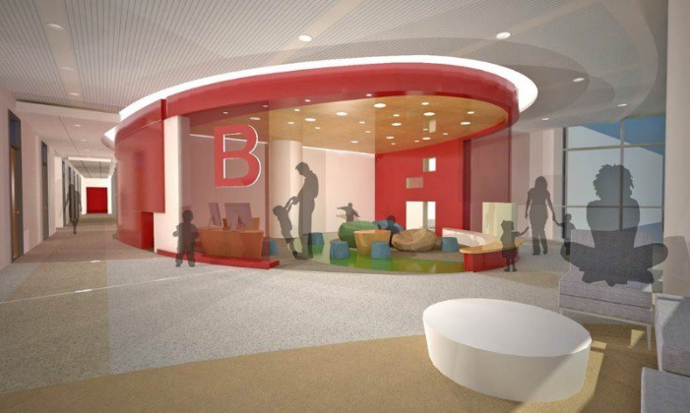Waiting Areas

## Waiting areas and lobbies area available on throughout the hospital. See pages X-XX.

For safety reasons and to prevent accidental blocking of the retractable fire doors, do not rearrange furniture in the waiting areas. This will help prevent accidental blocking of retractable fire doors.

## Restroom Locations

### Public restrooms and water fountains are located on every floor near the public elevators. Staff Only restrooms require badge access and are generally near staff lockers, lounges and conference rooms. See pages X-XX.

### Bicycle Storage

### Bicycle parking is available on a first come, first serve basis.

### The bicycle storage is located on the first floor in room 1388, accessible via first floor 27th Street or Cesar Chavez front entrance (through conference center corridor).

### Badge access is required to access the bicycle storage room 1388.

### Reserved bicycle space may be available. Contact the Parking Office, 415-600-1986 (confirm with Rigo) to register to use this facility and to program your badge for access.

### First floor showers are available, however items cannot remain stored for day use.

### Lockers within the shower/locker area are only used while utilizing the shower facilities. Day use lockers are available on department floors.

### Additional bicycle racks are available at the 27th St. and Cesar Chavez entrances.

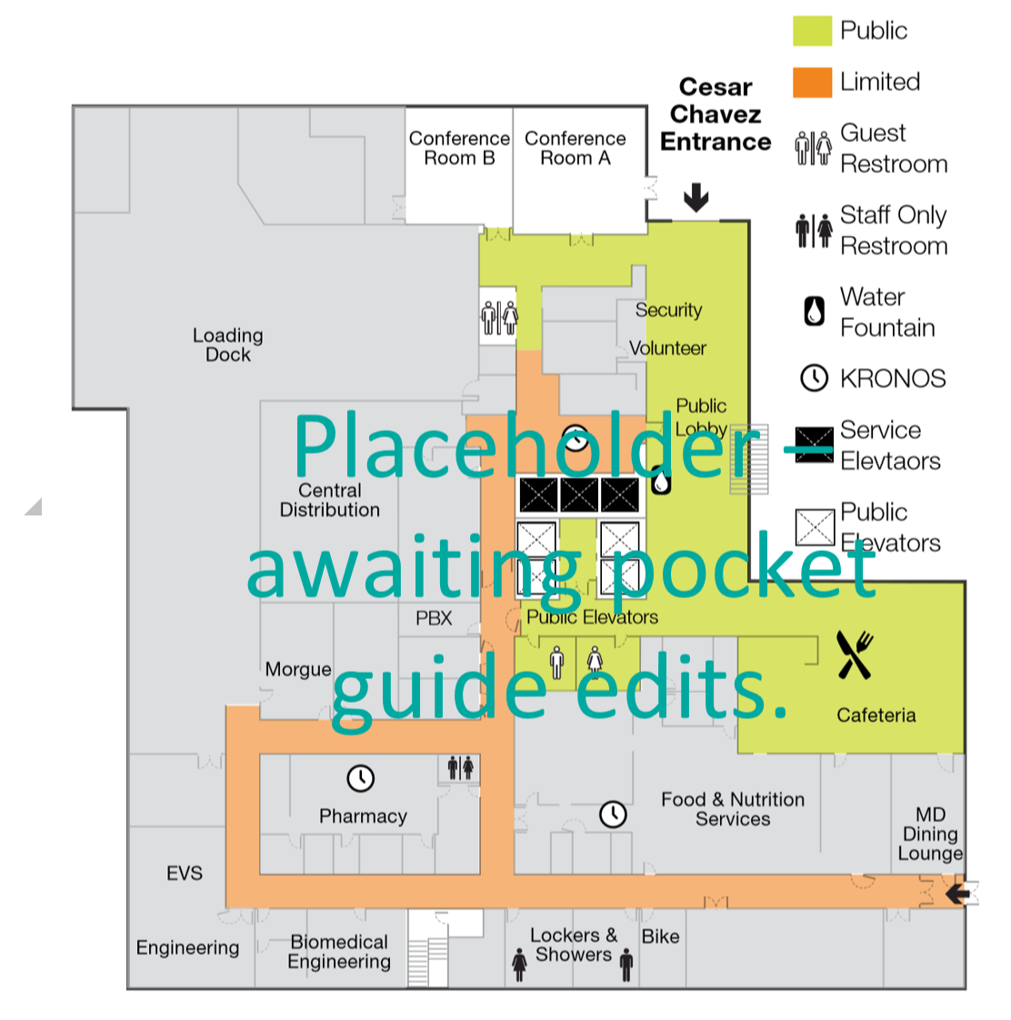

Water Cooler/Bottle Filling Stations

Mission Bernal Campus is a sustainable and LEED certified building. Please do your part and help reduce the use of disposable bottle water.

* Bottle filling locations are in the Emergency Department, Cafeteria, and Surgical Waiting Room.
* Water fountains are available on each floor near the elevators.
* Plumbed coffee makers with hot water dispensers are available on certain floors.
* Ice makers are available inpatient nourishment rooms (not in staff lounges).

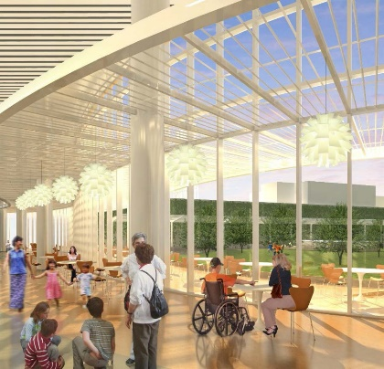Dining Services

Several choices for food and beverages are available during regular business hours. The Cafeteria and Grab and Go are on the first floor, to the left of the elevators and are open Monday – Friday, from 6:30 a.m. – 6:30 p.m. They are closed after hours and on weekends.

#### Snack and beverage vending machines are located on the second floor near the public elevators.

Catering Services

#### All catering requests must be submitted to the Food & Nutrition Services Department three days in advance of the meeting or event.

#### Use Catertrax, the ordering platform to order food for meetings. Place catering orders on [www.cpmc-stlukes.catertrax.com](http://www.cpmc-stlukes.catertrax.com). For training on Catertrax, go to [https://catertrax-1.wistia.com/medias/ojoa2vlyhm#](https://catertrax-1.wistia.com/medias/ojoa2vlyhm).

Room Reservations

To reserve a room, complete **Online Conference Room Request** form, <http://dcpwdbs405/virtualems/>. event. This is a duplicate of information mentioned earlier

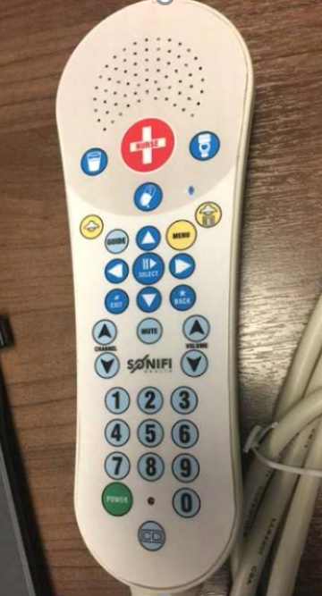Patient Entertainment / Education (Powered by Sonifi) Eric- Jim B indicates you have a much better pix of this handset!

Rooms are equipped with a multi-purpose media system capable of providing patient education, communication and entertainment features:

* + - Access the full complement of TV Programming
    - Review assigned educational content
    - Complete questionnaires
    - Order patient meals
    - View care team information
    - Access patient medical schedule
    - Interact with their care team
    - Use convenient controls and Volume Integrated into Pillow Speaker

## Lactation Lounge

## A dedicated lactation lounges for physicians and staff only is located on the Fifth Floor, Room 5357 (page xxx). Badge access is required.

Ambassador Service Suite

The Ambassador Services Suite is a hospitality space located on the third floor near the Clinical Lab/Blood Bank of Mission Bernal Campus. It is our way of saying “thank you” to our most generous philanthropic donors, as well as volunteers with more than 500 hours of service per year to CPMC.

Guest Internet Access (Wi-Fi)

Mission Bernal Campus offers complimentary internet access. To connect, select **“SHGUESTNet”** as the wireless network. Follow the prompts on the device, including accepting the "Terms and Conditions of Use."



Equipment and Furnishing

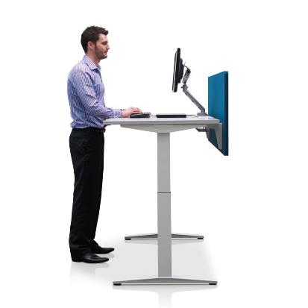

Ergonomics

Ergonomic chairs and keyboard trays are fully adjustable. For assistance on proper chair and keyboard adjustment, please contact Safety Department at 415-600-4620 or email sforzok@sutterhealth.org. They will send materials regarding self-assessments and if needed will direct you to complete the online ergonomic assessment.

Office Spaces

Office spaces include the following:

* Ergonomic chairs
* Ergonomic keyboard trays
* Electric sit/stand desks
* Monitor arms
* Electrical outlets on the desktop for device charging
* Mobile personal storage - keys will be provided for assigned locations
* Task lighting

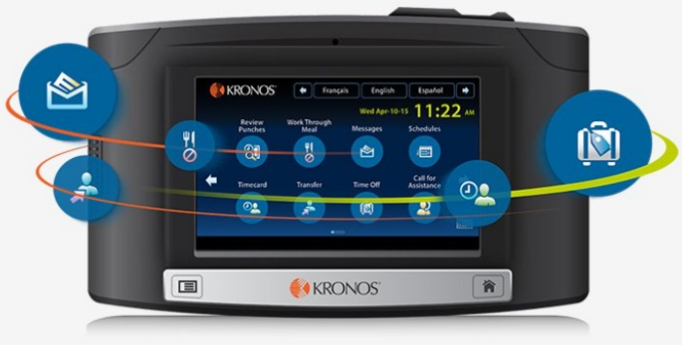Kronos Time Clocks

New InTouch wall clocks are located throughout the campus, conveniently positioned near:

* + - Elevator lobbies
    - Main corridors
    - Lab & Pharmacy
    - Some Staff Lounges
    - Web Application will also be available for some users

Telephone System

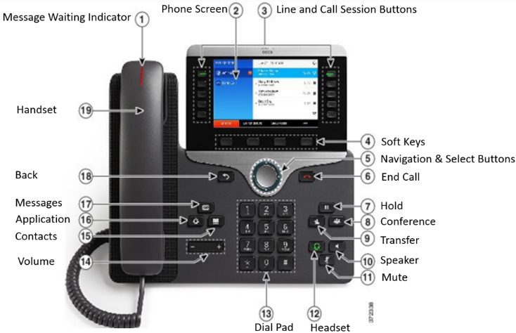Cisco Voice over IP (VoIP) phones are used at Mission Bernal Campus, including desk, wall and wireless phones. In addition to the standard features of traditional phones (hold, speaker phone, call forwarding, conferencing, muting), the Cisco phones offer:

* + - * Cisco Unity voicemail
      * Connects to the Vocera badge application, allowing calls can be made between telephones and Vocera badges.
      * Informacast for paging and broadcast messaging

Emergency red phones will be installed in key locations.

Multi-Function Printers (Scan, Print, Copy)

Multi-function networked printers are located throughout the facility and can function as copiers, scanners and printers. Print jobs can be retrieved by tapping your badge on the sensor located on the printer of your choice. Some workflows will default to specific printers (such as in the ED).

For copier and printer support, call Sutter Health Service Desk at 888-888-6044 or by going to IS.SUTTERHEALTH.ORG.

Fax Machines

Most faxing will be done using RightFax. There will be a limited number of traditional fax machines on the campus in areas where electronic faxing is not possible.

Faxes will be received into an electronic inbox, can be read online, and can be saved or printed. Use the RightFax application to send faxes by scanning and sending. Sutter EHR will fax records automatically as required by clinical workflows.

PBX/Phone Operating System

Hospital Operators will be located at both the Van Ness and Mission Bernal Campuses. Hospital Operators will have Nurse Call and other alarm panels to assist in routing alerts.

Vista Point Enterprise Operator Services System (phone console) will support the hospital operator workflows and assist in the management of call queues, routing and call handling statistics.

HIPAA - Confidential Document Containers

Confidential document containers are located throughout the hospital and are emptied every two weeks by the shredding company.

If the containers need to be emptied prior to the regularly scheduled pick-up, call Support Services (x67900) to arrange for EVS assistance.

Mission Bernal is dedicated to being a green facility, however, so please remember to THINK BEFORE YOU INK.

Sustainable Waste Removal

Mission Bernal is designed to be a green hospital. This includes recycling, composting, red-bag (biohazard), pharmaceutical and toxic waste management and medical equipment reuse.

In office spaces and public areas, receptacles are provided for co-mingled recycling (blue) and regular trash (black). In the staff lounges and conference rooms there are receptacle for co-mingled recycling (blue), regular trash (black), and composting (green).

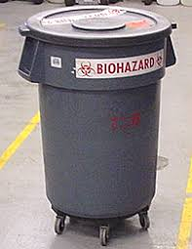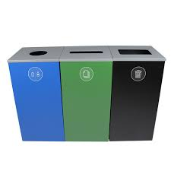

Vocera

The Vocera badge delivers hands-free, real-time voice communication between the wearer and other staff members. This communication system weighs less than two ounces, allowing users to keep their hands free without the burden of carrying a smartphone.

Nurse Call System

The Nurse Call Rauland Responder 5 system is an application which allows the patient to alert staff from the bedside, among other patient locations. Identified alerts will integrate with other applications in order to produce hospital-wide communications and notification acknowledgement and generates a number of reports. The system utilizes devices at the bedside and in the patient room to accomplish three primary functions:

1. It serves as a code required system for patient safety & security.
2. It provides a patient alert-communication system (for hospital staff) which assists patients and allows for increasingly efficient hospital operations.
3. It interacts with other systems to provide access to patient entertainment and education.

Temperature Monitoring

Mission Bernal Campus uses a combination of two systems to monitor and alert if an equipment temperature goes out of range - the AeroScout system ( in the refrigeration units) and the MobileView system.

### When a device’s temperature goes out of range during department hours of operation:

### A primary alert is sent to the department through MobileView

### A secondary alert is sent to Plant Operations.

### When a device’s temperature goes out of range when the department is closed,:

### Primary and secondary alerts are sent to Plant Operations.

Eric-per Jim B, we need to get a better pix from Bob Andrews – not sure if the little box on top of this pix is accurate

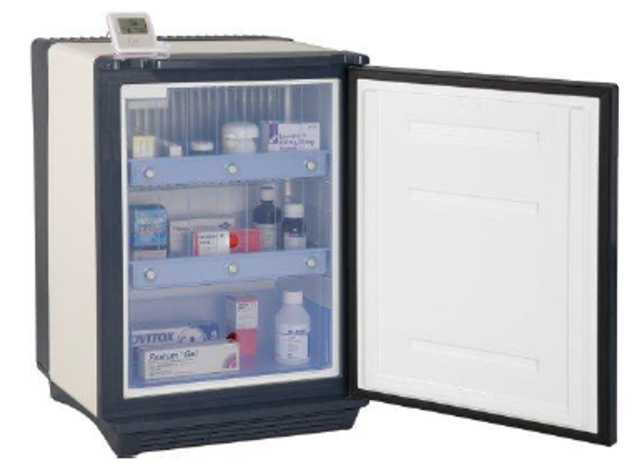

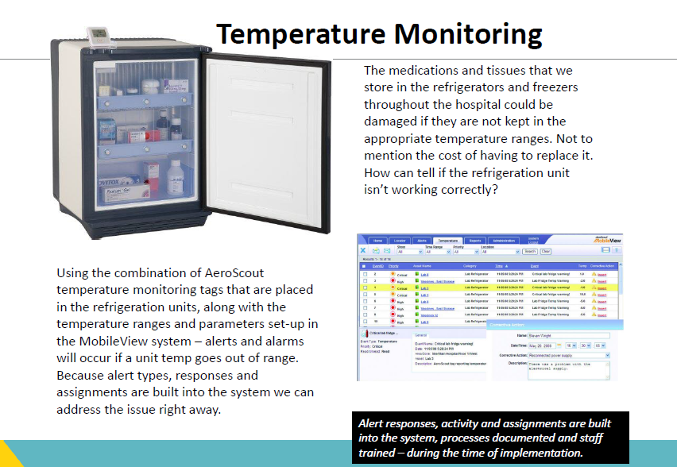

Patient Lift System and Mobile Lifts

Patient lift systems are available in med/surg and ICU patient rooms. Patient lifts are a safety feature to assist in patient mobility and reduce the risk of associated employee injuries. In addition, mobile lifts are available for use in patient care areas, to assist with patient mobility, where ceiling lifts are not available.

Do you want a picture of the lift system?

Pneumatic Tube System

The pneumatic tube system will assist with transporting medications, lab specimens and blood products to/from patient care areas, to expedite patient care. The system has an enhanced “secure send” functionality which will only allow appropriately licensed staff to send and receive medication and blood products.

We should consider having a picture of a carrier … here is a picture of a pneumatic tube station

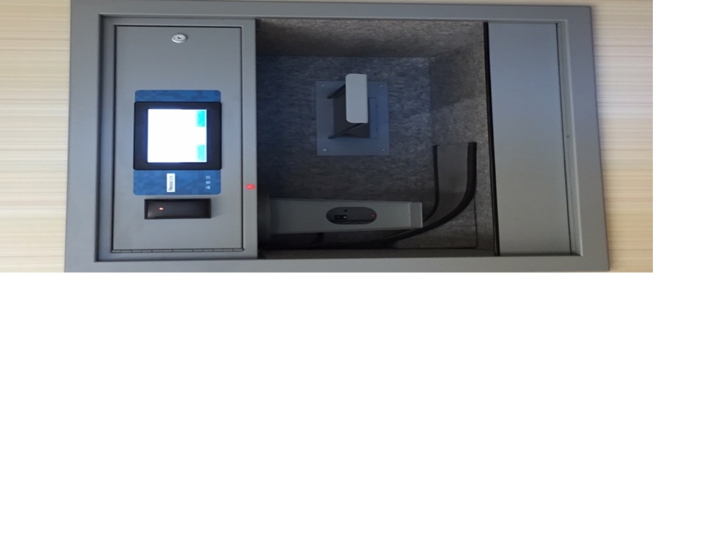



Supplies and Restocking

Remove this blank page

## Loading Dock / Unloading

## The Mission Bernal Campus loading dock is located off Cesar Chavez St. on Level 1. Interior access is adjacent to the service elevator.

•Supply Chain Overview

* Supply chain staff will monitor supply levels and the automated supply system will generate refill requisitions to order inventory.
* Supply Chain will receive delivery from our primary distributor at 8PM Monday through Friday.
* Supply Chain will remove corrugated cardboard at the loading dock as per infection control policies and deliver supplies to the Pyxis and supply cart areas throughout the hospital.
* •Nurse Server carts are department specific and are non-standard storage options some departments use. Supply Chain does not manage or replenish supplies on these carts.

Supply Chain & Medical Gas Area

The supply chain area is located on Level 1, room number 1522, adjacent to the loading dock. Staff, supplies, and receiving will be staged here to support a Low Unit of Measure (LUM) Just in Time (JIT) distribution model.

The Supply Chain team is responsible for the replenishment of medical gases, housed in the Medical Gas storage room on Level 1, accessed directly off the loading dock in room 1518.

The Code Blue Cart quick reference guide can be found here: <http://mysutter/bay/CPMC/About/News/Department%20Newsletters/CrashCarts.pdf>

Broselow quick reference guide can be found here: <http://mysutter/bay/CPMC/Clinical/Nursing/Need%20to%20Know/BroselowCrashCart.pdf>

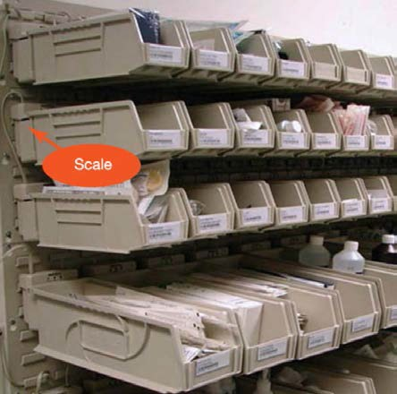Supply Chain Stat Requests

Par Levels for supplies on the units will be calculated for four days of inventory on hand. Supply Chain Staff will manage the restocking and storage of Code Blue/ Broselow resuscitation and isolation carts.

Supply Chain staff will be onsite between the hours of 7 a.m. to 4:30 p.m., Monday - Friday. For supply needs during evening and weekends, follow current process and contact the Nursing Supervisor who has access to the distribution storage area.

Normal Business Hours Central Distribution: **x86626**

Normal Business Hours Receiving**: x86901 CHECK WITH RAY. DIFFERENT IN POCKET GUIDE**

Supply Chain Intranet requests: <http://apps.insidecpmc.org/CPMC_SRQ/servlet/LoginServlet?cpmc_role_id=180>

Pharmacy

The Pyxis Supply management system will be used in a combination of locked and unlocked cabinets.

Pharmacy staff will make twice daily medication deliveries to inpatient units, and once daily deliveries to ancillary departments, including new Pyxis Anesthesia carts.

Controlled substances are mostly filled in Pyxis, but may be picked up at the Pharmacy by Nursing for one-time medications. Pharmacy staff will make daily rounds to remove discharged orders.

Equipment Cleaning

There is a central medical equipment cleaning process for the following types of equipment

* PCA Pumps
* Sequential Compression Devices
* Infusion pump modules
* Infusion pump control units
* Seizure pads
* Feeding pumps

Equipment will be preliminarily wiped down by EVS before leaving the patient room, and temporarily placed in the soiled utility room. The medical equipment cleaning team will round on floors and follow the process outlined here.

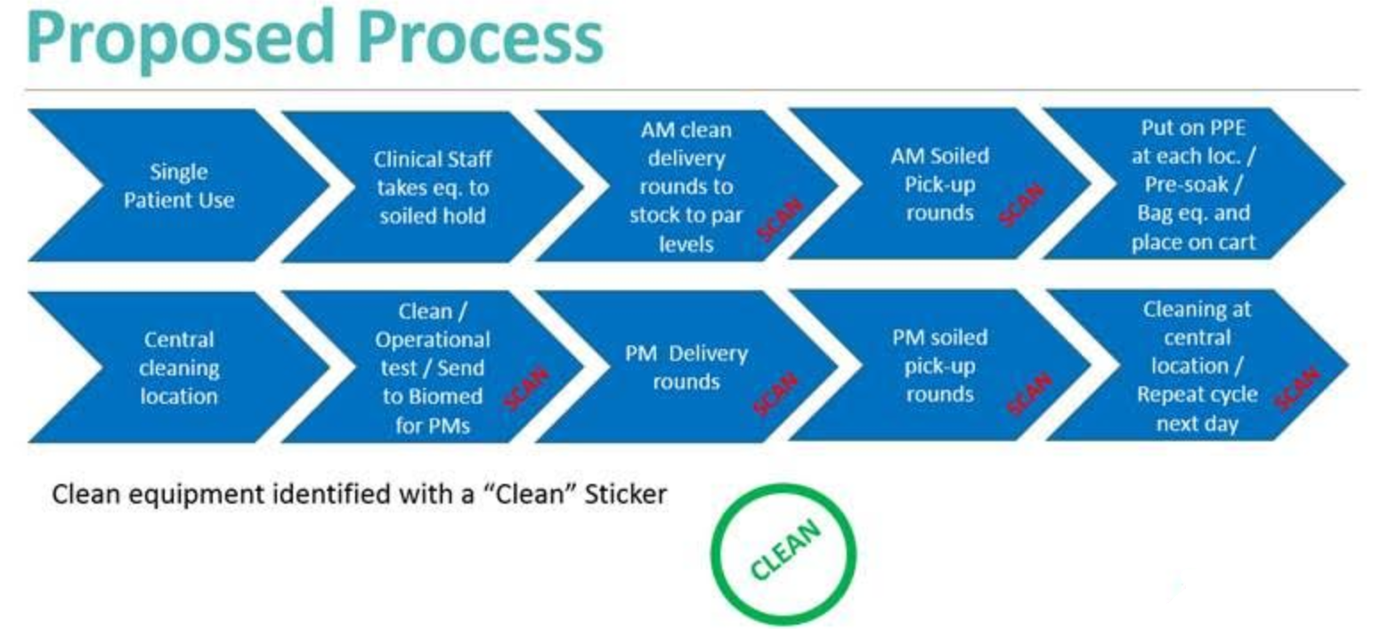

Asset Management

AeroScout is the chosen RFID (Radio Frequency Identification) equipment location system. Essential equipment that moves will be targeted for RFID tracking.

Items that will have RFID locating include but are not limited to:

|  |  |
| --- | --- |
| * Beds * Bladder Scanners * Defibrillators * EKG machines * Gurneys * IV pump brains & modules * Other infusion pumps (mobile) | * Patients, infants or child (HUGS System) * PCA pumps * Portable imaging machines * SCD * Vital sign monitors * Wheelchairs |

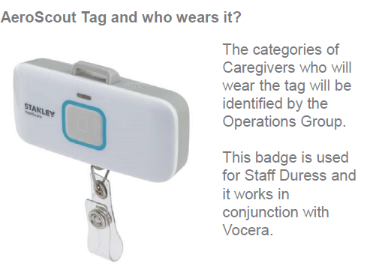STAFF DURESS.

**STAFF DURESS**

**Eric- please move the copy to the right of the tag to bullets under the following bullet**

* + - Staff will be able to silently notify Security for assistance. Security will be able to locate the staff in need, via the RFID tag.

Durable Medical Equipment (DME)

The DME process will be the same as currently in place with consigned inventory available in certain closets near patient care areas in the ED (Room 2334), OR/PACU (Room 3201) and Inpatient Units (Rooms 4334,5334,and 6334). DMEs will be replenished by our DME partner Pacific Medical.

Linen

Linen will be managed and delivered by EVS at Mission Bernal Campus just as it has been managed at St. Luke’s. Clean linen will be stored in Room 1404, next to the Materials Management area adjacent to the loading dock.

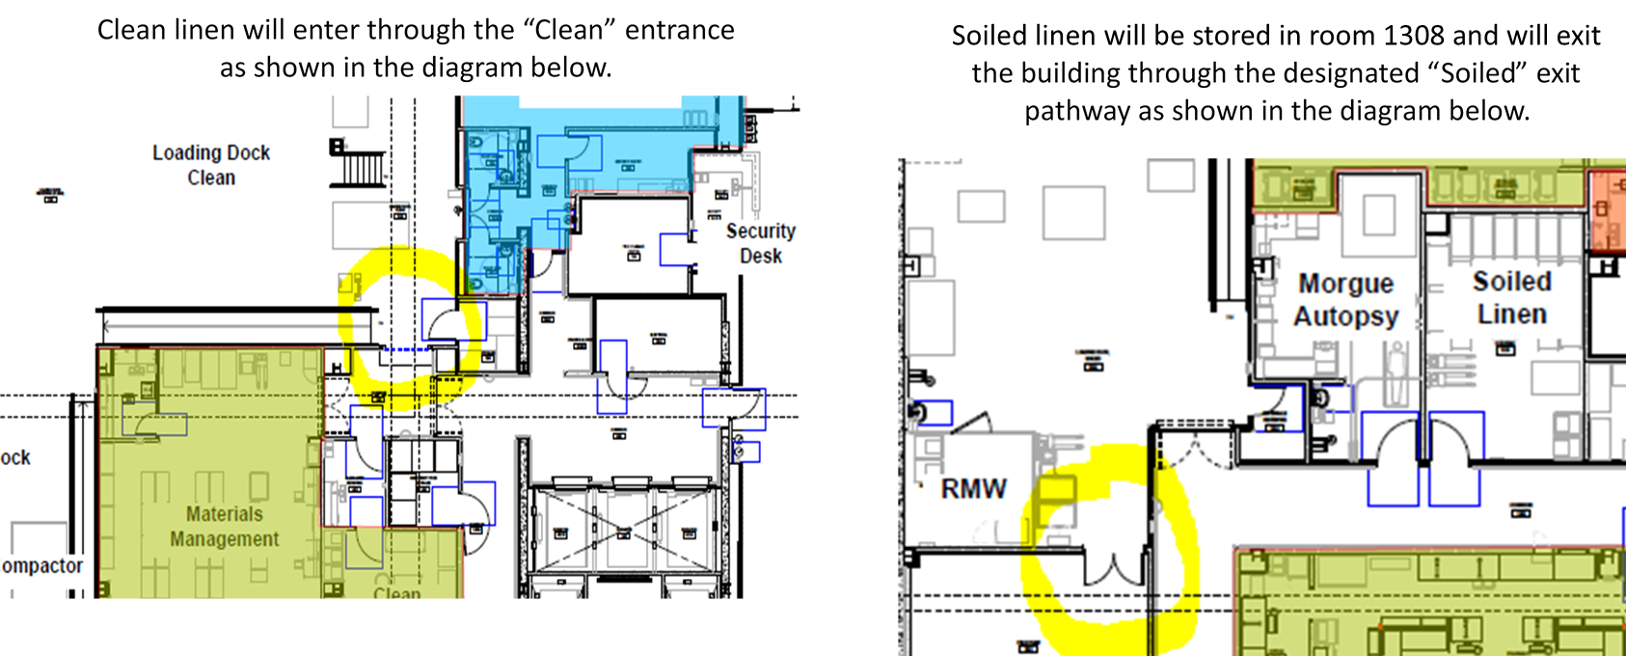

How to Order Stationery, Forms, and Brochures on the Intranet

For customized stationery and Rx pads: order through SmartWorks.

**For Forms:**

Order forms through Standard Register, which you can access through Lawson. Here are the steps:

* + 1. Go to **All Services**, then **Requisition Center**, **Shopping**, enter your requesting location (a five digit number).
    2. Go to **Find/Shop** icon, then **OneSource**; scroll down to **Standard Register**.
    3. See icons on top – click on browse catalog icon and find **Sutter CPMC forms**. Or, for quick search, enter the form number and/or name.
    4. Specify your quantity and complete your order for approval.

**For Brochures and Various Marketing Materials**

Order brochures, fact sheets, folders, marketing materials, logos, photos, artwork etc. from Sutter Health through Workamajig.

1. Go to the Sutter Intranet marketing page (mysutter/marketing)
2. Fill out the Workamajig request form
3. If you don’t have a Workamajig account, send an email to linten@sutterhealth.org.

ERIC ADD ARTWORK-Examples of each